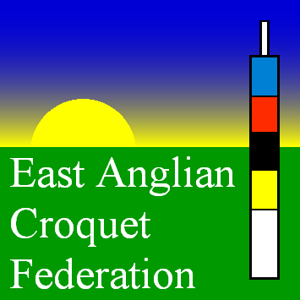
East Anglian Croquet Federation
Golf Croquet 2015 League Entry Form

Level Play League:
The Club wishes to enter ………. Team(s) in the EACF Golf Croquet Level Play League for the 2015 year. Enclosed is the Entry Fee of £10.00 per team.
Entry Fee
a): Team Contact Team Name .
email: Tel. No.
b): Team Contact Team Name .
email: Tel. No.
_______________________________________________________
Handicap League:
The Club wishes to enter ………. Team(s) in the EACF Golf Croquet Handicap League for the 2015 year. Enclosed is the Entry Fee of £10.00 per Team.
a): Team Contact Team Name .
email: Tel. No.
b): Team Contact Team Name .
email: Tel. No.
_______________________________________________________
Total Entry Fee:
Please return completed form together with cheque made out to ‘The East Anglian Croquet Federation’ to the League Manager: Dr John Noble, 98 Wilbury Road, Letchworth, Herts SG6 4JJ by the 31st March 2015. Forms may instead be emailed to patricia_noble@sky.com.

Club Secretary Date

